**PROJECT REPORT ON**

**Competition Class Website**

**Parisharam Classes**



GRAPHIC ERA DEEMED TO BE UNIVERSITY DEHRADUN

Submitted to

Department of Computer Applications

in partial fulfilment for the award of the degree of

MASTER OF COMPUTER APPLICATIONS

**Batch (2016-2019)**

***Submitted by***

Namit Singh

Enrolment Number:

GE-16111373

**Under the Guidance of**

Mr. Harendra Singh Negi (Assistant Professor)



**CANDIDATE’S DECLARATION**

I hereby certify that the work presented in this project report entitled “_______________________________________________________**”** in partial fulfilment of the requirements for the award of the degree of Bachelor of Computer Application is a bonafide work carried out by me during the period of January 2018 to June 2018 under the supervision of **Mr. Harendra** Sir Department of Computer Application, Graphic Era University, Dehradun, India.

This work has not been submitted elsewhere for the award of a degree/diploma/certificate.

**Name and Signature of Candidate**

This is to certify that the above mentioned statement in the candidate’s declaration is correct to the best of my knowledge.

**Date: ____________ Name and Signature of Guide**

**Signature of Supervisor Signature of External Examiner**

**GUIDE CERTIFICATE**

This is to certify that the Project work titled “**Competition Class Website**” submitted by Mr Namit Singh for the partial fulfilment of the degree of M.C.A. from **Graphic Era Deemed to be University**, Dehradun during the year 2016-2019. This is the original work carried out by the student as internal project in the institution under my supervision as internal guide.

Supervisor’s Signature:

Supervisor’s Name: Mr. Harendra Sir

Supervisor’s Designation: Asst. Professor

Date:

Place: Dehradun

Forwarded for evaluation by the Head:

Dr. S.C. Dimri

Prof.&Head,

Department of Computer Applications

**ACKNOWLEDGEMENT**

I fell pleasure to acknowledge my sincere thanks to Dr. Sushil Dimri Sir who offered outstanding opportunity.

I take this opportunity to my express profound gratitude and deep regards to my teacher MR.HARENDRA SINGH NEGI for his for his exemplary guidance, monitoring and constant encouragement throughout the course of this project. The help and guidance given by his time to time shall carry me a long way in the journey life on which I am about to embark.

I also take this opportunity to express a deep sense of gratitude to all my teachers,

For their cordial support valuable information and guidance, which helped me in completing this task through various stages.

I am obliged to staff members of GEU for the valuable information provided by them in their respective fields. I am grateful for their cooperation during the period of my assignment.

Lastly, I thank almighty my parents, brothers, sisters and friends for their constant support without which this assignment would not be possible.

Namit Singh

Master of Computer Applications

2016-2019

Graphic Era University

Dehradun-248001

**Abstract**

The main objective of this project is to bring the awareness in Students life regarding government jobs competition exams preparations. Most of the students thought that to get a government job is very difficult. But the fact is it is very easy. By the help of this website students can get the genuine information regarding government jobs exams.

With the help of this site students can easily download the previous years questions papers for their practise.

Students can also appear in online exam for Self Evaluation. So many students can give test at same time without any interrupt. Students will get genuine information on this site regarding any competition exams specially government exams.

**Table of Contents**

1. Introduction………………………………………12

1.1 Project Overview

1.2 Purpose

1.3 Scope

1.4 Sub Module of Online Exam Portal

1.5 Purpose of This Module

2.Software Requirements and Specifications (SRS)…23

2.1 Type of Requirements

2.1.1 Functional Requirements

2.1.2 Non Functional Requirements

2.2 Hardware and Software Requirements.

2.3 Software Development Methodolody

2.4 Life Cycle Models

2.5 Example of Incremental Model

3. Software Design…………………………………..30

3.1 Data flow Diagrams

3.2 Symbols for Data flow Diagrams

3.3 DFD for Registration Module

3.4 DFD for Login Module

3.5 Database Design

3.6 ER Diagrams

3.7 Database Schema for Website Signup

3.8 Database Schema for Online Exam Portal Signup

4. Implementation and Coding…………...............92

4.1 Coding for Website

4.2 Coding for Online Exam Portal

4.3 Coding for Website Bank. php

5. Software Testing……………………………98

5.1 Objectives of Software Testing

5.2 Unit Testing

5.3 Integration Testing

5.4 System Testing

5.5 Alpha Testing

5.5 Beta Testing

5.7 Acceptance Testing

6. Maintenance……………………………………..54

6.1 What is Maintenance

6.2 Why It is Required

6.3 Key Deliverables

7. Scope For Future Enhancement ……………......71

8. Conclusion………………………………………72

9. Bibliography……………………………………..

Chapter 1:

1. **INTRODUCTION**
   1. **Project Overview**

This Website is regarding awareness of government jobs exams .Basically it’s a Competition Class Website .

The main objective of this project is to help students who are not getting proper content regarding jobs in government sector.so in this site they will get complete information related to any topic of jobs.

Students can also download old questions papers from this site. Admin will update questions papers on regular basis and without any problem students can easily download all papers which will surely help students in many phases.

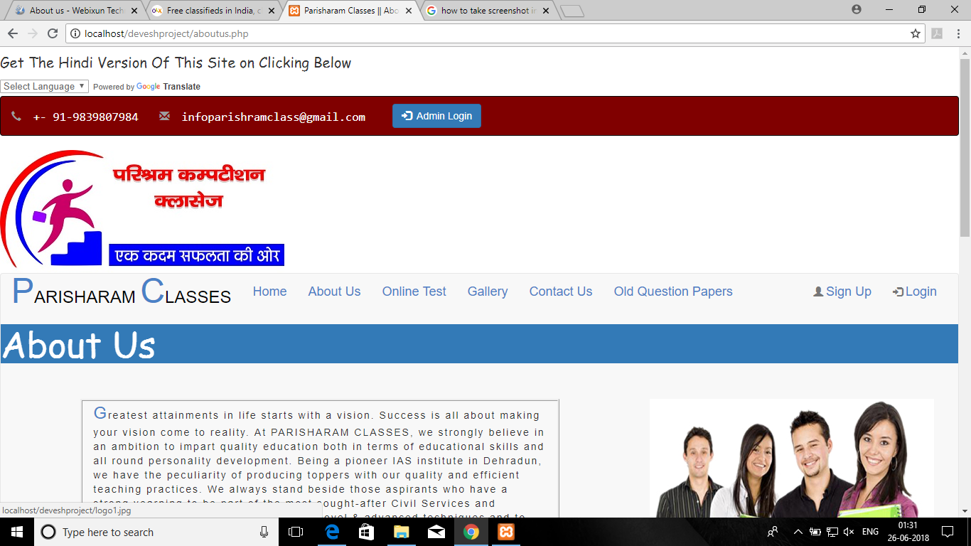

**1.2 Features**

1*.* Students can get genuine information related to any current government jobs exams here.

2. Students can also evaluate themselves with the help of online test software which is also available in this site.

3. Students can also download old questions papers related to any exam on year basis.

4. If you have any query related to any topic you can directly mail to the admin and you will get notification through email that your query has been sent and your problem will be solved As soon As Possible.

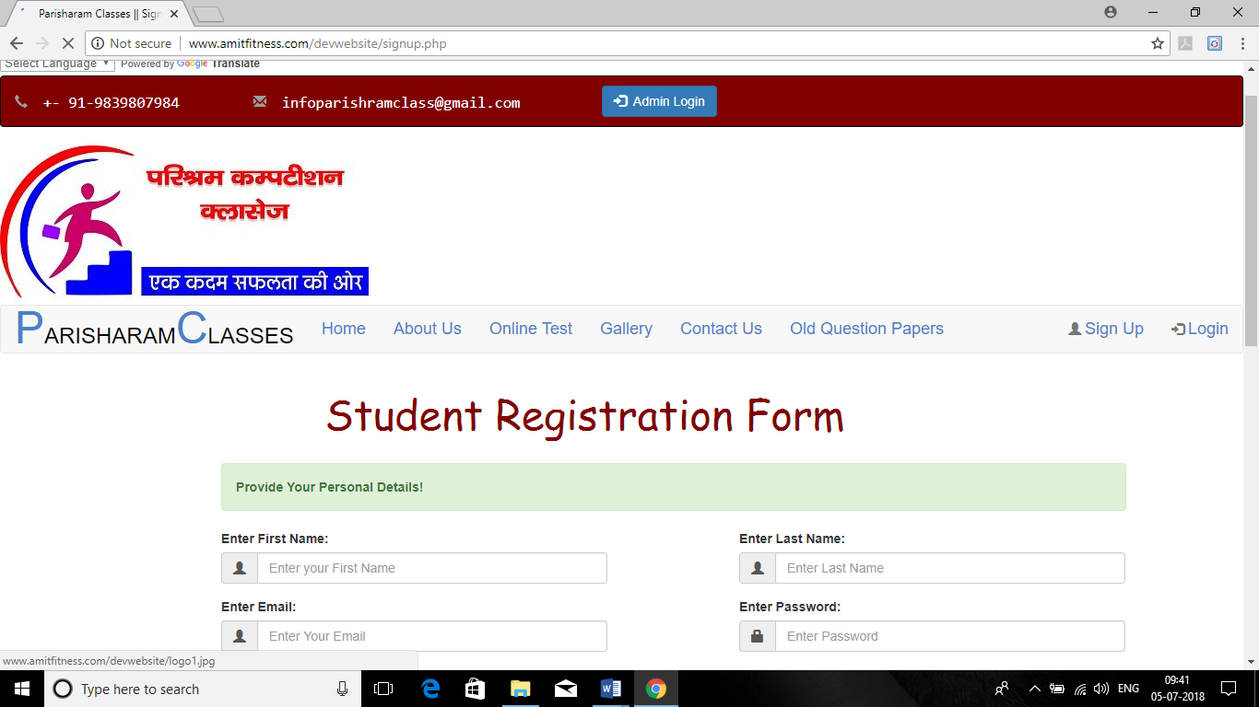

**1.3 Scope**

Site provides complete information related to any government jobs exams like exam pattern, previous years questions papers etc. if I talk about scope of this project than scope is very vast of this project because if any forms came in market then students don’t get complete information of that form or exam pattern or any other information related to that exams and they get confused that what to do so here they will get complete solution of their problems.

**1.4 Sub Module of online exam portal**

This is a web-based intelligent multiple-choice-question examination system, named Online Examination System (O.E.S) for assessing students.

It is a system by which students can appear in a quiz from anywhere of the world where there is no interaction between pencil and paper rather interaction between computer and human being.

The questions vary student to student for the same quiz while they are sitting in the quiz at the same time.

Teachers can use the O.E.S for evaluating students effectively, efficiently and perfectly. Any university, college, school or educational institute can use this system for their organization to take quizzes.

Today it is the more efficient and effective methods of assessing distant students. One of the main benefits of our system is automated marking, that is, teachers do not need to check the answer script as they do in manual quiz.

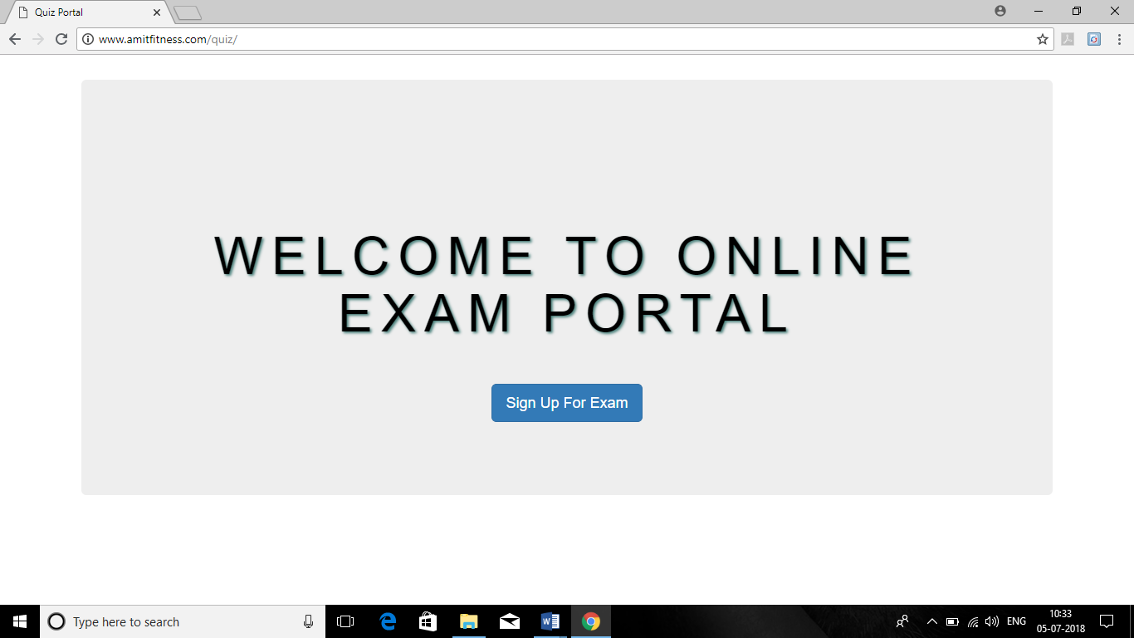

**1.5 Purpose of this module**

If I talk about competition class website and student can’t evaluate here then I think no need of that website.so here students can give online test on regular basis and they can see their results suddenly.

* It saves time as it allows number of students to give the exam at a time and displays the results as the test gets over, so no need to wait for the result. It is automatically generated by the server.
* Administrator has a privilege to create, modify and delete the test papers and its particular questions.
* Students can register, login and give the test with his specific id, and can see the results as well.

**Chapter 2**

**Software Requirements and Specifications.(SRS)**

This is one of the important phase of any software where we gather all the requirements for the project and once all the requirements completed then only we move to the other phase.

**Requirements may be:** What user wants in their project. If I connect this chapter 2 from my project then I want images form client which I will use in his website. Videos that I will use in his website. Which questions papers he wants to be uploaded in his website that I also wants.

The one very important is content like what content he would like to be displayed on his website.Because once the content is effective then only the traffic will come on site.

**“ A software requirements and specifications is a description of software system to be developed. ”**

**2.1 Types of Requirements:**

* **Functional Requirements**
* **Non –Functional Requirements.**

**2.1.1 Functional Requirements.**

Basically functional requirements means that what our software is going to do. Or if I talk in detail then it is nothing just the features of the software.

Example:

1. Mail Receiving System:

Once user will ask any query then he /she will fill the query form and then he will receive email that his/her query has been sent successfully.

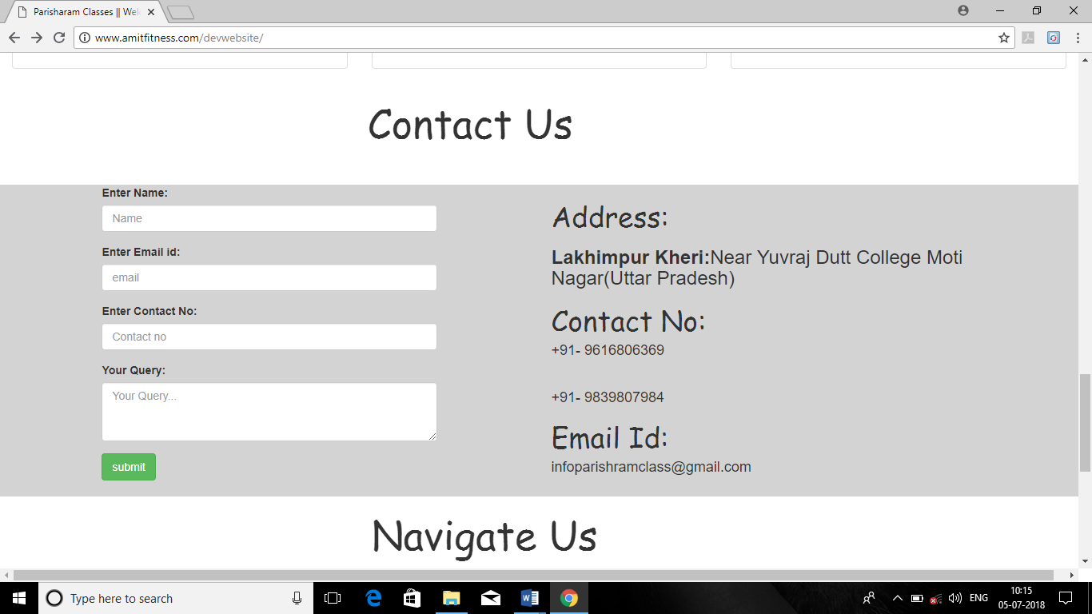

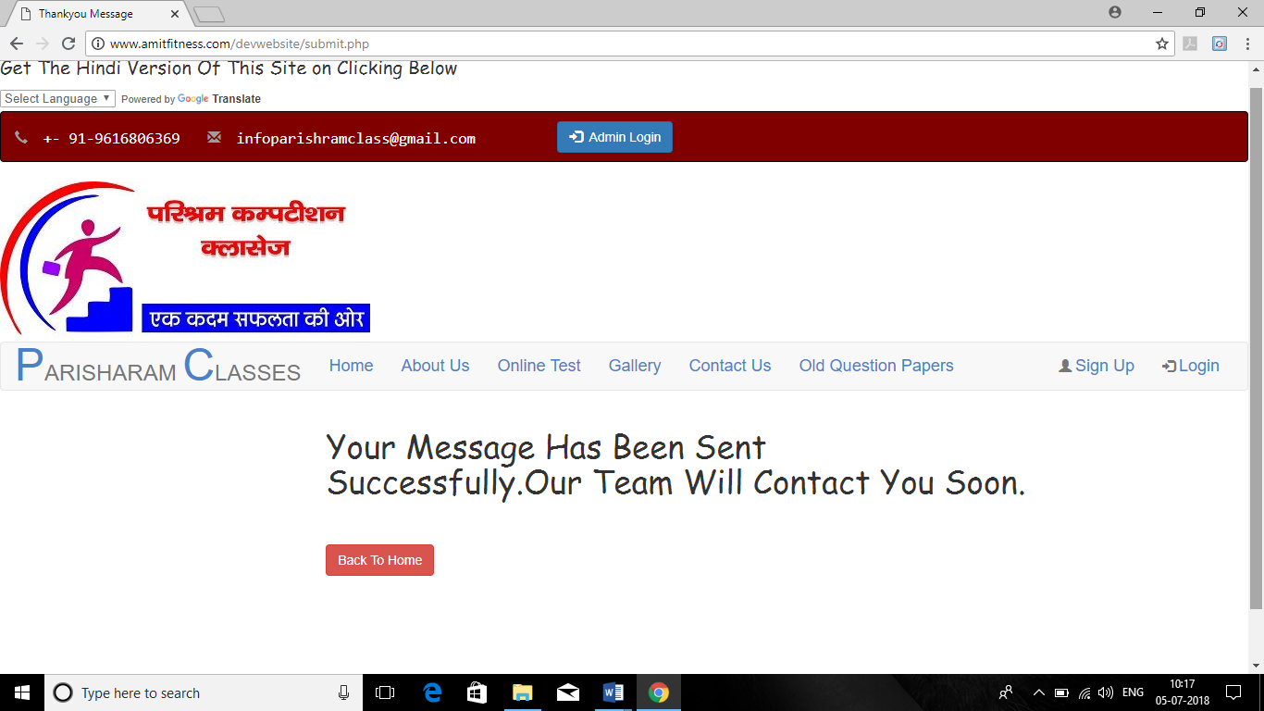

2. Forgot password module:

If user forgot his/her password then will enter his/her email id and he will receive an OTP on his mail and once OTP match then he /she can continue the procedure to change the password. Most of the time users forgot their password then it very important to add this module in website.

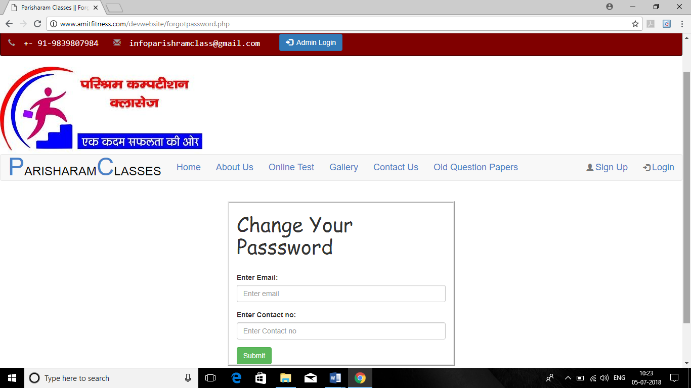

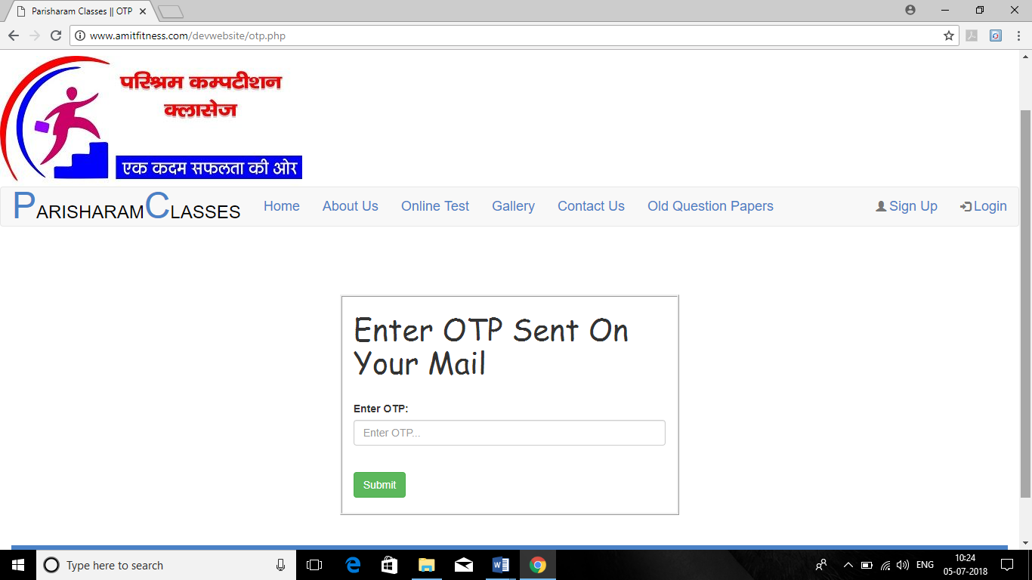

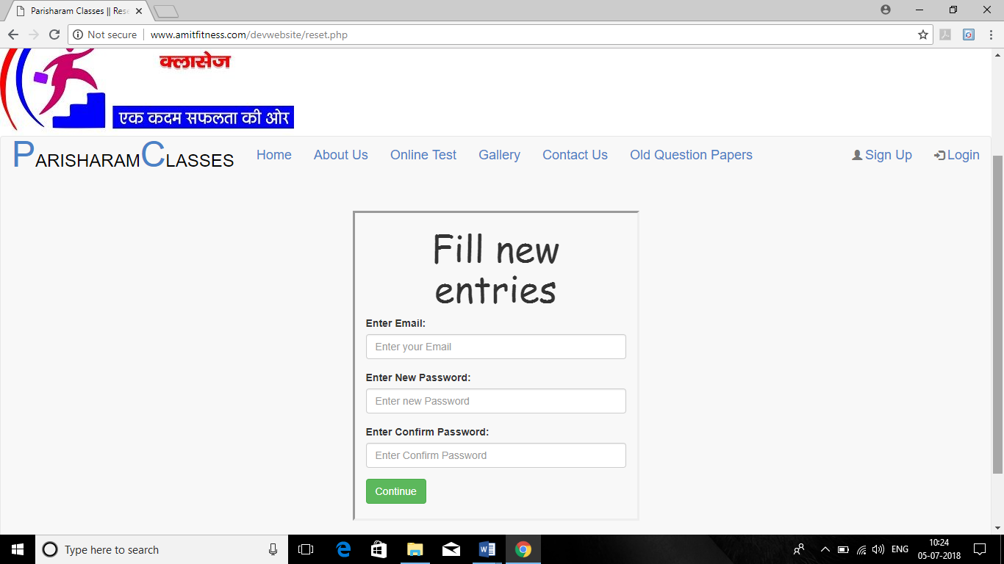

3: Download the old Questions papers:

If user wants to download the previous questions papers. Then he/she can easily download the papers form site.

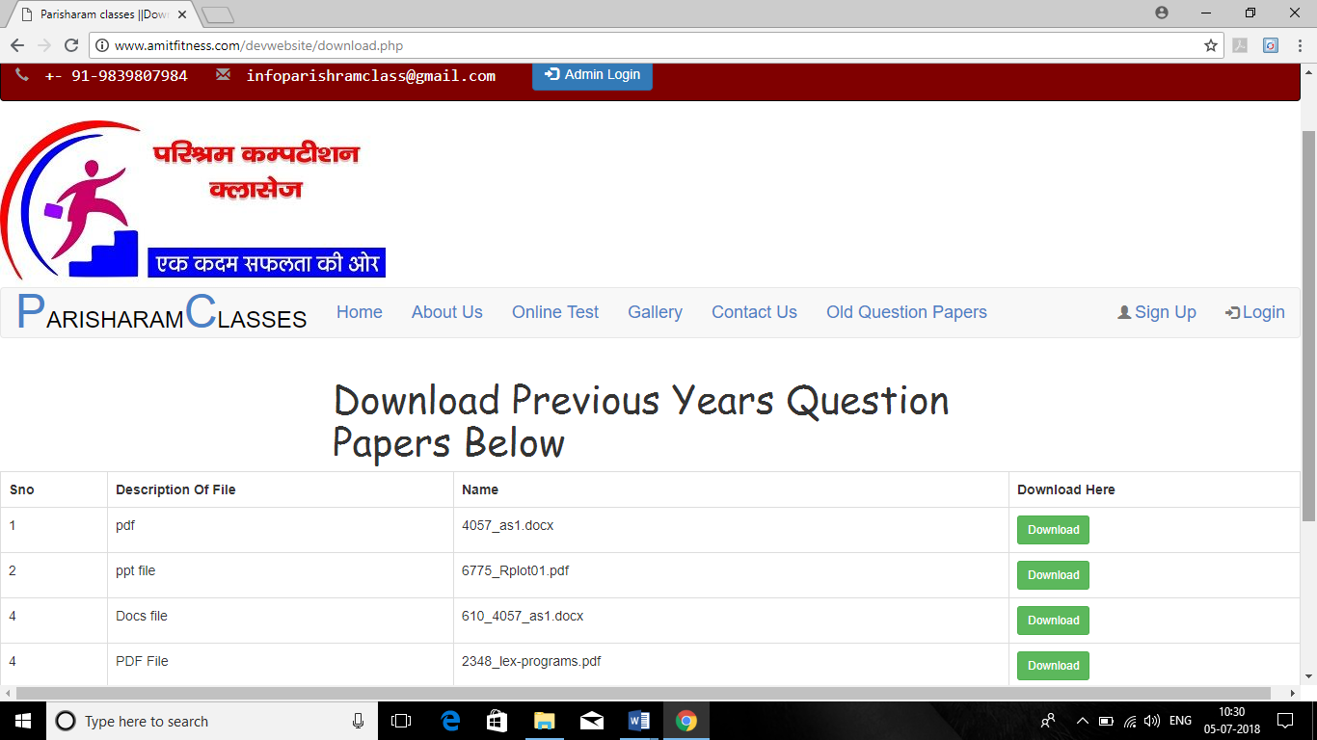

**4:** Online Exam Portal:

If user wants to give the exam for Self Evaluation then he/she can easily give the exam by simple one Registration and after Login.

Suppose students learn something new then he/she can evaluate himself/herself in online exam portal.so many students can give exam at same time without any interrupt.

Admin will add questions of different subjects on regular basis and students can easily appear in exam. Because self evaluation is very important.



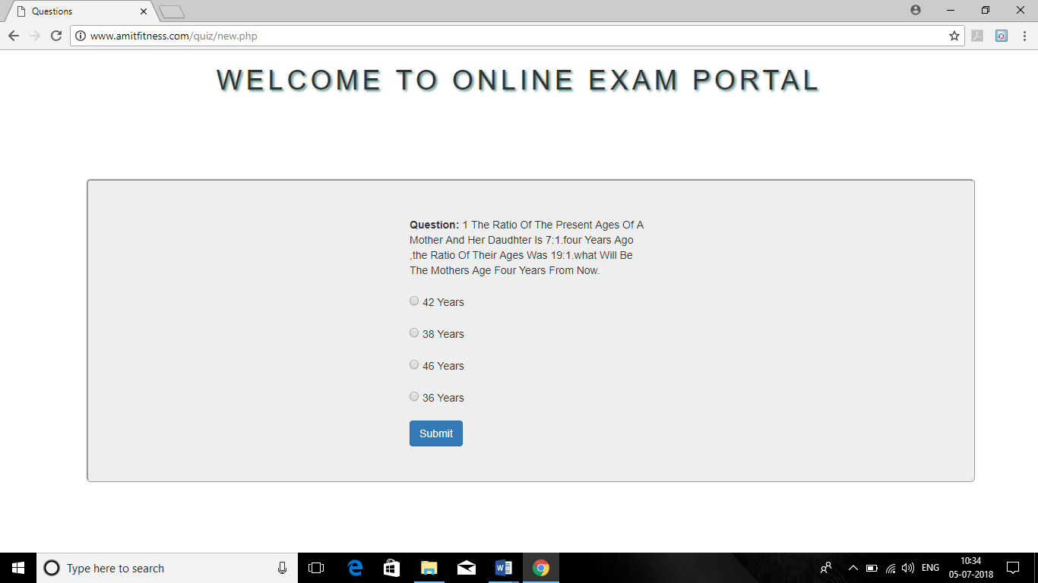

**2.1.2 Non Functional Requirements.**

Non Functional requirements means that how my modules are going to be performed. Non Functional requirements are not straight forward requirements.

If I relate Non Functional requirements to my project then one Non Functional requirement may be that this website should be available for users 24/7.

**Its main aim is to judge the operation of the system rather than specific behaviour.**

Example of Non Functional:

* Time taken for the system to retrieve data from the Database.
* Security of the users data
* Ability of the system to handle if large no of users login at same time.

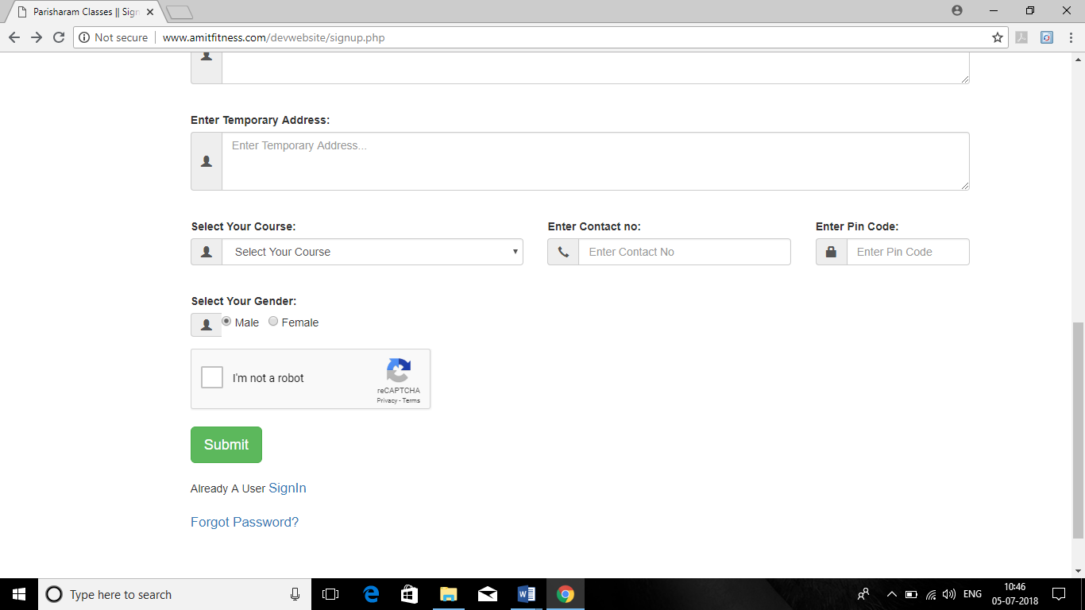

This may be one example of Non Functional Requirements that without check this CAPCHA button user not able to signup.it will maintain the security of the system.

**2.2 Hardware and Software Requirements**

2.2.1 Client side Requirements- Desktop/ Laptop with internet connection.

Browser updated version (Chrome, Mozilla).

**2.3 Software Development Methodolody**

The establishment and use of sound engineering principles in order to obtain economically developed software that is reliable and works efficiently on real machines is called *software* *engineering.*

***Software engineering*** is the discipline whose aim is:

1. Production of quality software

2. Software that is delivered on time

3. Cost within the budget

4. Satisfies all requirements

**Software process** is the way in which we produce the software. Apart from hiring smart, knowledgeable engineers and buying the latest development tools, effective software development process is also needed, so that engineers can systematically use the best technical and managerial practices to successfully complete their projects.

A **software life cycle** is the series of identifiable stages that a software product undergoes during its lifetime .A software lifecycle model is a descriptive and diagrammatic representation of the software life cycle.

A life cycle model represents all the activities required to make a software product transit through its lifecycle phases .It also captures the order in which these activities are to be taken.

**2.4 Life Cycle Models**

There are various life cycle models to improve the software processes.

* + WATERFALL MODEL
  + PROTOTYPE MODEL
  + ITERATIVE ENHANCEMENT MODEL
  + EVOLUTIONARY MODEL
  + SPIRAL MODEL
  + INCREMENTAL MODEL

In my project I followed Incremental Model the reason is:

Because we are not a professional developers we are just making this project for learning purpose.so our requirements are not fixed and we are making project with our own requirements. Suppose we learn some new technology and we want to add this in our project again our requirements change with time.

So for students incremental modal is best modal to implement any project.

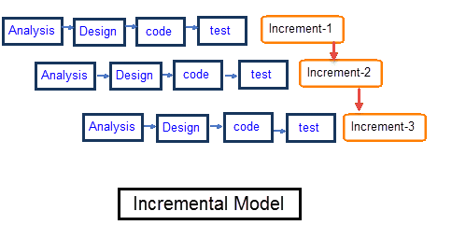

In incremental model the whole requirement is divided into various builds. Multiple development cycles take place here, making the life cycle a [“multi-waterfall” cycle](http://istqbexamcertification.com/what-is-waterfall-model-advantages-disadvantages-and-when-to-use-it/).  Cycles are divided up into smaller, more easily managed modules. Incremental model is a type of software development model like [V-model](http://istqbexamcertification.com/what-is-v-model-advantages-disadvantages-and-when-to-use-it/), [Agile model](http://istqbexamcertification.com/what-is-agile-model-advantages-disadvantages-and-when-to-use-it/) etc.

**2.5 Example of Incremental Modal**

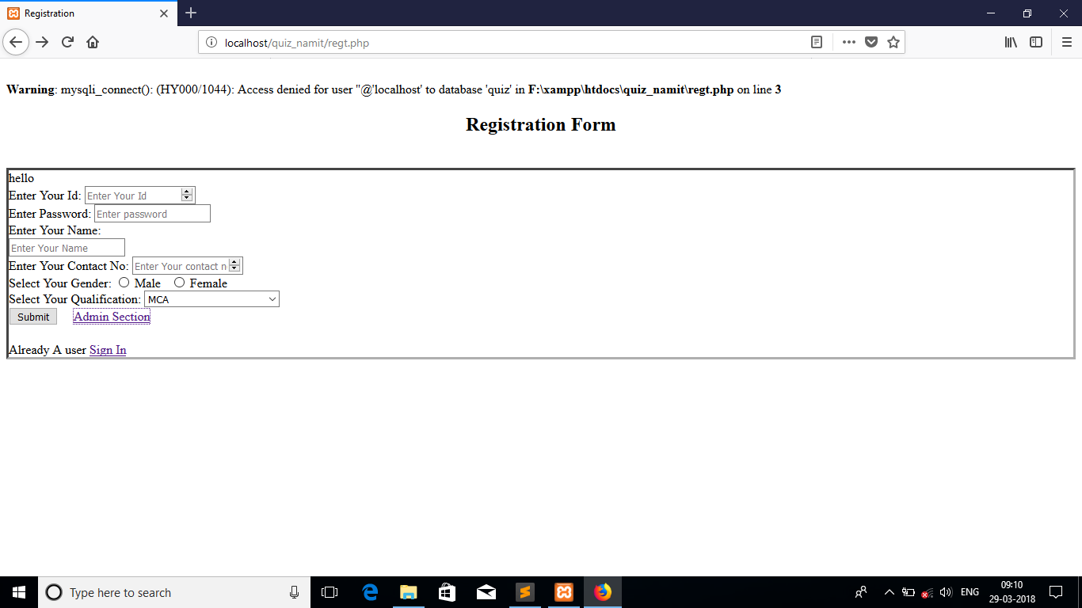

Firstly I don’t know the technology of Bootstrap then I simply design the form.

After learning the Bootstrap I added this technology in my project. Now on adding this technology my site in now complete responsive which is very important for any site nowadays.

Now user can also select his/her security questions to change his/her password.

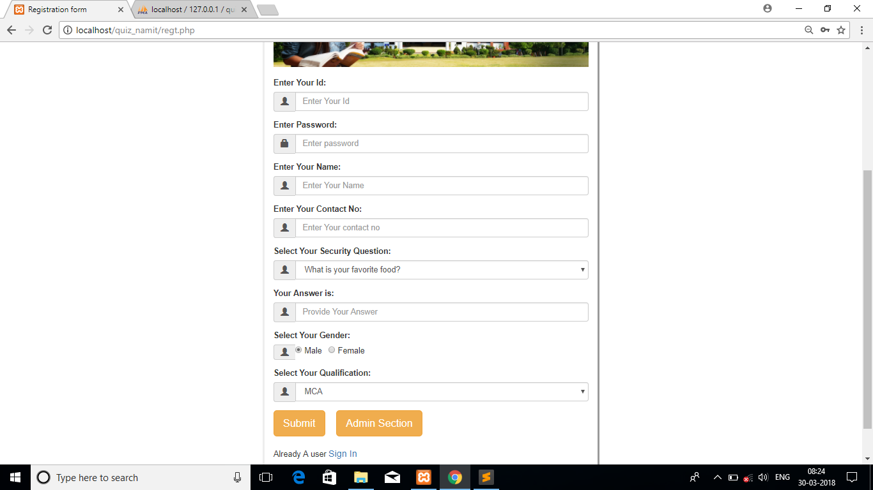

You can also see that in first form there is not option for Security question but in the updated form I also added option for Select Security Question Option for Users.

**So this is the advantage of using Incremental Modal we can do the work as per our requirements changes with time.**

Chapter 3

**Software Design**

This is also one of the most important phases of software development life cycle.in this phase. Its aim is to create a blue print for the implementation .the main focus of the software design is to cover the gap is understanding the specifications.

sS 7

What To Built

Conceptual Design

How To Built

Technical Design

In this phase, the data, facts and figures will be generated by checking various documents related to system. It also covers interviews of the persons who belong to the system. The problems in the current system will be identified and necessary improvements will be recommended. Thus a new system, as a solution will be proposed. The emphasis is on the type of the information, the new system should provide, the required frequency and accuracy of results and other considerations. The activities of analysis phase will be least structured and more people oriented.

**3.1 Data Flow Diagrams.**

Data flow diagrams is a graphical representation of Flow of data through on information system .Modelling its process aspects.

A data flow diagrams are basically used as an preliminary to create an overview of the system without going into great detail which can later be elaborated.

It basically shows which kind of information will be input to and output from the system, how the data will advance through the system and where the data will be stored.it does not show the process timing or whether process will operate in sequence or parallel .

**3.2 Symbols used in data flow diagrams.**

1. For External Entity

2 Process

3 Data flow

4 Data Base

**3.3 Data flow diagram for registration module**

User

Id only Number

Password min 5 char

If alphabet

Fill Name

If not Min length 5

Fill Answer Invalid No

Verification Done

If Name Blank

If Blank

If Less than 10

Otherwise

Stored In DataBase

**3.4 Data Flow Diagram for Login Module**

Login With Id And Password

Else Login Again

If Matches From Data Base

Else Login Again

Start Test

If Matches from Database

**3.5 Data Base Design**

Data Base is very important for any software if data base is not design properly then so many problems can be face at time of coding.so to design the proper schema of database first we have to design the ER Diagram of database if relationships Exists between two or more tables.

**3.6 ER Diagrams**

ER Diagrams helps us to understand the relationships between the two or more tables that how data will manage between two or more tables.

Example:

Gives

Loan

**3.7 Database Schema for Website**

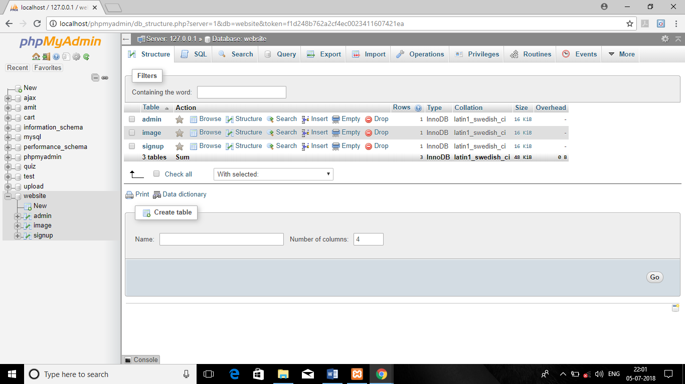

We have to design the database in such a way that one primary key should be there in every table to distinguish the same data.

Suppose when we work in project like voting system then we have to use the proper constraints like Primary key, Unique key.

Because on that project the person who voted once cannot vote for next time.similar case with inline quiz portal the person who had already given the test cannot give the test once more with same email id.

**3.8 Database Schema for Online Quiz Portal**

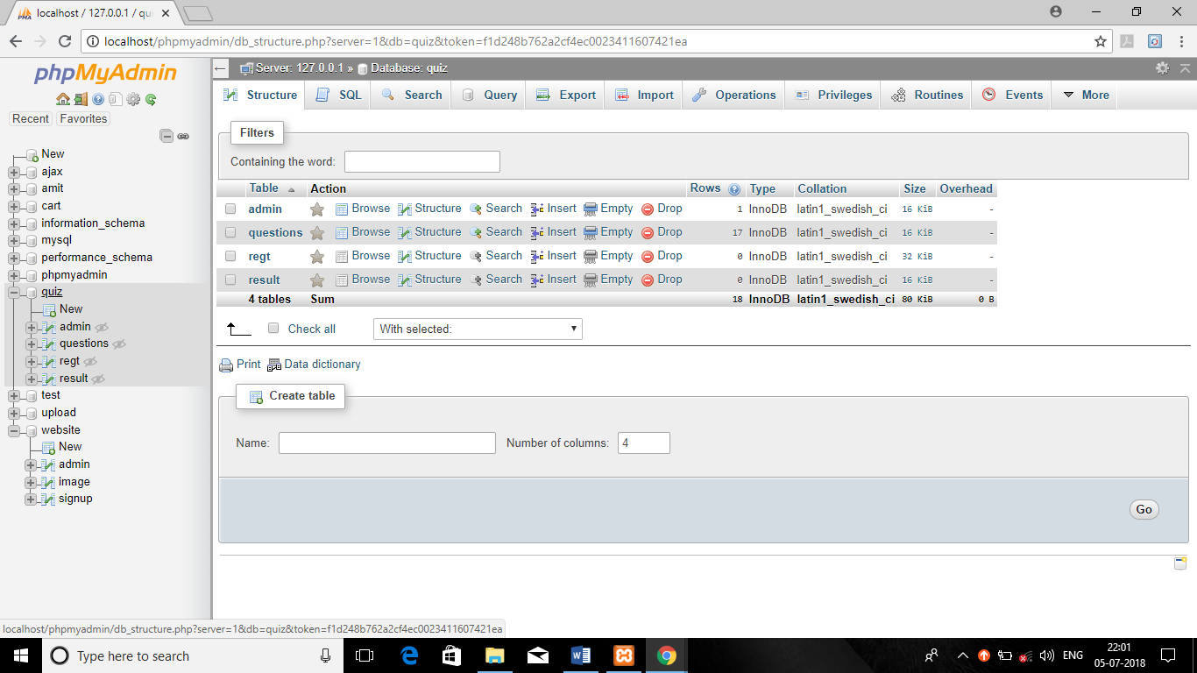

Here in this database I also used primary key concept and auto increment concept.

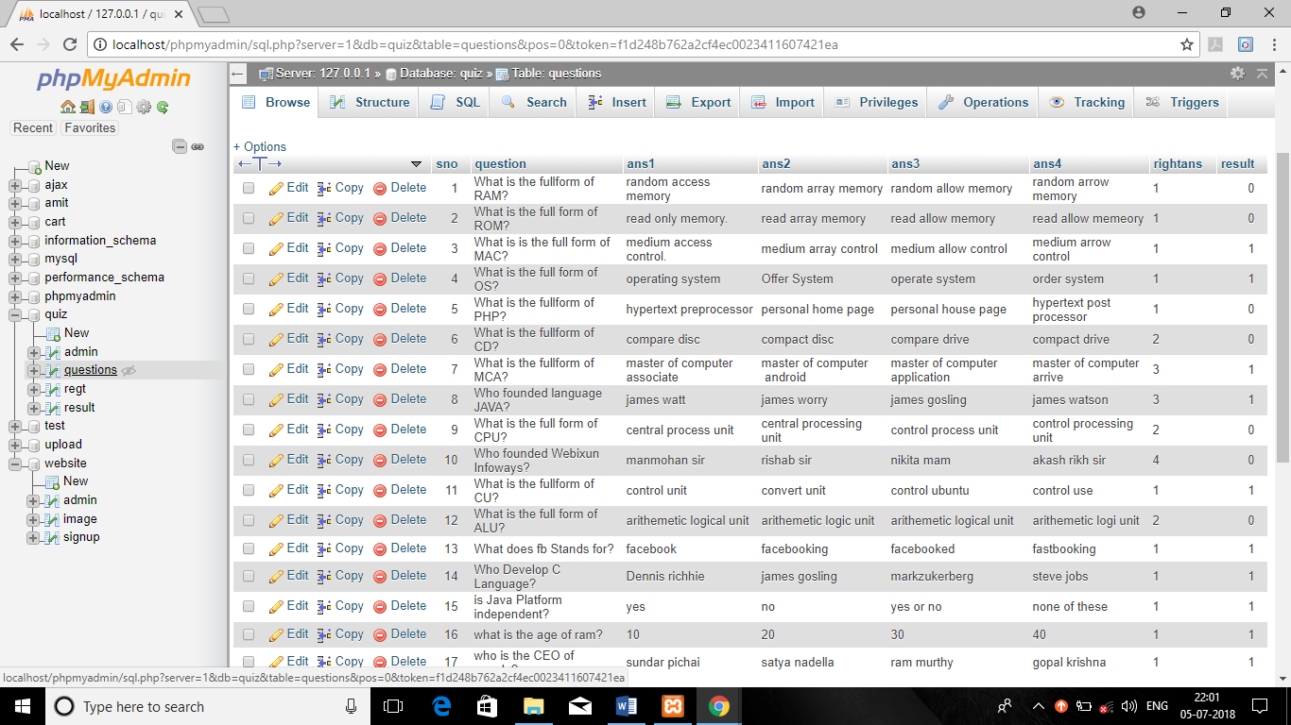

**3.9 Use case Diagram or Sub module Online Exam Portal**

Use cases describe how the system-to-be from a user’s perspective. It used to show the *functions* to be supported by the system. Here is the use case diagram of OES system.

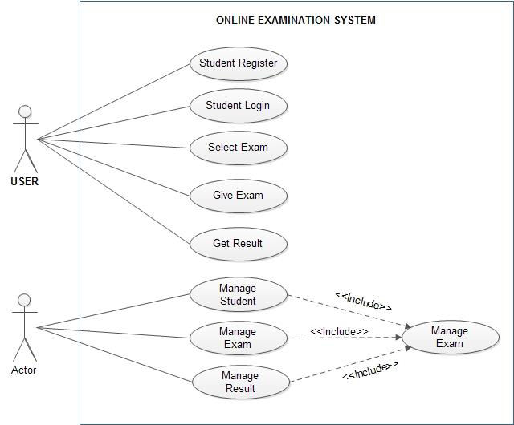

**Chapter 4**

**Implementation and Coding**

This is the actual phase where we convert all the collected requirements into the coding. According to me without this phase no project exists. all the above phase are theoretical phases but this is the practical phase in which the actual implementation take place. Coding is one of the most important phase of software development life cycle.

**4.1 Coding for Website (index.php)**

<?php

ob_start();

?>

<?php

include_once('database.php');

if(isset($_POST['email'])&& isset($_POST['password']) && isset($_POST['contactno']))

{

if(!empty($_POST['email']) && !empty($_POST['password']) && !empty($_POST['contactno']))

{

$email=$_POST["email"];

$password=$_POST["password"];

$contactno=$_POST["contactno"];

$sql="select * from admin where email='$email' and password='$password'";

$query=mysqli_query($con,$sql) or die($con->error);

if($query->num_rows==1)

{

header('location:upload.php');

}

else

{

echo '<script>alert("Login Invalid");</script>';

}

}

else

{

'<script>alert("Fill");</script>';

}

}

?>

<!DOCTYPE html>

<html lang="en">

<head>

<title>Parisharam Classes || Welcomes</title>

<meta charset="utf-8">

<meta name="viewport" content="width=device-width, initial-scale=1">

<link rel="stylesheet" href="https://maxcdn.bootstrapcdn.com/bootstrap/3.3.7/css/bootstrap.min.css">

<script src="https://ajax.googleapis.com/ajax/libs/jquery/3.2.1/jquery.min.js"></script>

<script src="https://maxcdn.bootstrapcdn.com/bootstrap/3.3.7/js/bootstrap.min.js"></script>

<link rel="stylesheet" href="https://cdnjs.cloudflare.com/ajax/libs/font-awesome/4.7.0/css/font-awesome.min.css">

<div id="google_translate_element"></div><script type="text/javascript">

function googleTranslateElementInit() {

new google.translate.TranslateElement({pageLanguage: 'en', includedLanguages: 'en,hi', layout: google.translate.TranslateElement.InlineLayout.SIMPLE}, 'google_translate_element');

}

</script>

<script type="text/javascript" src="//translate.google.com/translate_a/element.js?cb=googleTranslateElementInit">

</script>

<style>

.jumb .jumbotron

{

background-image: url("s.jpg");

background-repeat: no-repeat;

background-attachment: fixed;

}

.jumbotron

{

background-color:#4a81c6;

}

.text-center .h1

{

letter-spacing: 4px;

}

.h .row

{

border-style: ridge;

background-color:#4a81c6;

}

.a .col-md-4 img:hover

{

border-radius:30%;

}

.b .col-md-4 img:hover

{

border-radius:30%;

}

.c .col-md-4 img:hover

{

border-radius:30%;

}

.d .col-md-4 img:hover

{

border-radius:30%;

}

.e .col-md-4 img:hover

{

border-radius:30%;

}

.f .col-md-4 img:hover

{

border-radius:30%;

}

#menunav2 :hover

{

color:black;

}

</style>

</head>

<body>

<!--Header Information-->

<div class="container-fluid">

<div class="row">

<nav class="navbar navbar-inverse" style="background-color:black;">

<ul class="nav navbar-nav">

<li><a href="#" class="glyphicon glyphicon-earphone"><big><font color="white"> <tt>+- 91-9839807984</tt></font></big></a></li>

<li><a href="www.gmail.com" class="glyphicon glyphicon-envelope"><big><font color="white"> <tt>deveshkumarverma@gmail.com</tt></font></big></a></li>&nbsp;&nbsp;

<button style="margin-top:10px;" type="button" data-toggle="modal" data-target="#myModal" name="submit" class="btn btn-primary"><span class="glyphicon glyphicon-log-in"></span> &nbsp;Admin Login</button>

</ul>

</nav>

</div>

</div>

<!-- Modal -->

<form method="post">

<div class="container-fluid">

<div class="row">

<div class="col-md-7"></div>

<div class="col-md-5">

<div class="modal dialog">

<div class="modal-content">

<div class="modal-header">

<button type="button" class="close" data-dismiss="modal">&times;</button>

<h4 class="modal-fade" id="myModal" role="dialog">

<div class="modal-title" style="font-size:40px; font-family:'lobster two',cursive;">Admin Login</h4>

</div>

<div class="modal-body">

<div class="form-group">

<label>Enter Email:</label>

<div class="input-group">

<span class="input-group-addon"><i class="glyphicon glyphicon-user"></i></span>

<input type="text" id="name" name="email" class="form-control" placeholder="Enter EmailId" required>

</div>

</div>

<div class="form-group">

<label>Enter Password:</label>

<div class="input-group">

<span class="input-group-addon"><i class="glyphicon glyphicon-user"></i></span>

<input type="Password" id="password" name="password" class="form-control" placeholder="Enter Password" required>

</div>

</div>

<div class="form-group">

<label>Enter Contact No:</label>

<div class="input-group">

<span class="input-group-addon"><i class="glyphicon glyphicon-user"></i></span>

<input type="number" id="contactno" name="contactno" class="form-control" placeholder="Enter Contact No" required>

</div>

</div>

<input type="submit" name="submit" class="btn btn-primary" value="Submit">

</div>

</div>

</div>

</div>

</div>

</div>

</div>

</div>

</ul>

</nav>

<a href="logo1.jpg" target="_blank"><img class="img-responsive" src="logo1.jpg"></a>

<!--Menu Bar-->

<nav class="navbar navbar-default">

<div class="navbar-header">

<button type="button" class="navbar-toggle" data-toggle="collapse" data-target="#myNavbar">

<span class="icon-bar"></span>

<span class="icon-bar"></span>

<span class="icon-bar"></span>

</button>

<a class="navbar-brand" href="#"><font size="5"><font color="#4a81c6" size="7">P</font><font color="black">ARISHARAM</font><font color="#4a81c6" size="7">C</font><font color="black">LASSES</font></font></a>

</div>

<div class="collapse navbar-collapse" id="myNavbar">

<ul class="nav navbar-nav">

<li><a href="index.php"><big><font color="#4a81c6" size="4">Home</font></big></a></li>

<li class="dropdown">

<a href="aboutus.php"><big><font color="#4a81c6" size="4">About Us</font></big></a>

</li>

<li><a href="www.amitfitness.com/quiz"><big><font color="#4a81c6" size="4">Online Test</big></a></li></font>

<li><a href="#"><big><font color="#4a81c6" size="4">Gallery</big></a></li></font>

<li><a href="#contactus"><big><font color="#4a81c6" size="4">Contact Us</big></a></li></font>

<li><a href="download.php"><big><font color="#4a81c6" size="4">Old Question Papers</big></a></li></font>

</ul>

<ul class="nav navbar-nav navbar-right">

<li><a href="signup.php"><span class="glyphicon glyphicon-user"></span> <big><font color="#4a81c6" size="4">Sign Up</big></a></li></font>

<li><a href="login.php"><span class="glyphicon glyphicon-log-in"></span> <big><font color="#4a81c6" size="4">Login</big></a></li>

</ul></font>

</div>

</div>

<!--Jumbotron Box-->

<div class="jumb">

<div class="jumbotron" style="min-height:500px">

<div class="text-center">

<h1 style="font-size:50px; font-family:'lobster two',cursive;"><font color="white">Welcome To Parisharam Classes</h1></br></br>

<h4 style="font-size:20px; font-family:'lobster two',cursive;">Come And Feel the Difference</font></h4> </br></br>

<a href="#namit" class="btn btn-primary btn-lg">Read More</a>

</div>

</div>

</div>

</nav>

<!--About Us -->

<div class="row">

<div class="col-md-3"></div>

<div class="col-md-6">

<h1 style="font-size:50px; font-family:'lobster two',cursive;">Our Mission And vision</h1></br>

</div>

<div class="col-md-6">

<center><h2 style="font-size:25px; font-family:'lobster two',cursive;">Our Mission</h2></center>

<div class="alert alert-info">

<p>Yes We know that our organisation is not very much old but we promise you that one day this organisation will become one of the finest organisation of Lakhimpur Kheri.

The Reason is we are only focusing on depth knowledge of each and every subject.

There are so many institutes where you get knowledge but only on outer surface but we are providing you the best knowledgein depth.</p>

</div>

</div>

<div class="col-md-6">

<center><h2 style="font-size:25px; font-family:'lobster two',cursive;">Our Vision</h2></center>

<div class="alert alert-info">

<p>Our vision is To Provide the Best quality Education to our Students so that One day they become success in their Lifes.

we are seeing us in 2 years one of the best coaching institutes in Lakhimpur Kheri.

To create the most trust worthy Competition Classes of the 21st century through support, to help individuals to explore their potential and achieve there galaxy.

</p>

</div>

</div>

</div>

</div>

<!--Our Courses-->

<div class="container">

<div class="row">

<div id="namit" class="col-md-4"></div>

<div class="col-md-4">

<h1 style="font-size:50px; font-family:'lobster two',cursive;">Our Courses</h1></br></br>

</div>

</div>

<div class="row">

<div class="a">

<div class="col-md-4">

<div class="thumbnail">

<a href="ssc.php" target="_blank">

<img src="ssc.jpg" alt="opps">

<div class="caption">

<center><p><font color="#4a81c6" size="6"><a href="ssc.php">SSC</font></center></p></a>

</div>

</a>

</div>

</div>

</div>

<div class="b">

<div class="col-md-4">

<div class="thumbnail">

<a href="bank.php" target="_blank">

<img src="bank.jpg" alt="opps">

<div class="caption">

<center><p><font color="#4a81c6" size="6"><a href="bank.php">BANK</font></center></p></a>

</div>

</a>

</div>

</div>

</div>

<div class="c">

<div class="col-md-4">

<div class="thumbnail">

<a href="l.jpg" target="_blank">

<img src="l.jpg" alt="opps">

<div class="caption">

<center><p><font color="#4a81c6" size="6"><a href="ias.php">LEKHPAL</font></center></p></a>

</div>

</a>

</div>

</div>

</div>

</div>

<div class="row">

<div class="d">

<div class="col-md-4">

<div class="thumbnail">

<a href="pcss.jpg" target="_blank">

<img src="pcss.jpg" alt="opps">

<div class="caption">

<center><p><font color="#4a81c6" size="6"><a href="pcs.php">TET</font></center></p></a>

</div>

</a>

</div>

</div>

</div>

<div class="e">

<div class="col-md-4">

<div class="thumbnail">

<a href="ias.jpg" target="_blank">

<img src="ias.jpg" alt="opps">

<div class="caption">

<center><p><font color="#4a81c6" size="6"><a href="railways.php">RAILWAYS</font></center></p></a>

</div>

</a>

</div>

</div>

</div>

<div class="f">

<div class="col-md-4">

<div class="thumbnail">

<a href="upp.jpg" target="_blank">

<img src="upp.jpg" alt="opps">

<div class="caption">

<center><p><font color="#4a81c6" size="6"><a href="upp.php">UPP</font></center></p></a>

</div>

</a>

</div>

</div>

</div>

</div>

</div>

</br>

<!--Contact Us-->

<body>

<form method="post">

<div class="row">

<div id="about us" class="col-md-4"></div>

<div class="col-md-4">

<h1 style="font-size:50px; font-family:'lobster two',cursive;">Contact Us</h1></br></br>

</div>

</div>

<!--Form For Contact Us-->

<form method="post">

<div class="container-fluid">

<div class="row" style="background-color:lightgrey; padding: 1p5x" >

<div class="hello">

<div class="col-md-1"></div>

<div id="contactus" class="col-md-4">

<div class="form-group">

<label>Enter Name:</label>

<input type="text" name="name" id="name" class="form-control" placeholder="Enter Name" required>

</div>

<div class="form-group">

<label>Enter Email id:</label>

<input type="email" name="email" id="email" class="form-control" placeholder="Enter Email" required>

</div>

<div class="form-group">

<label>Enter Contact No</label>

<input type="number" name="contactno" id="contactno" class="form-control" placeholder="Enter Contact no" required>

</div>

<div class="form-group">

<label>Your Message:</label>

<textarea rows="3" cols="25" id="area" class="form-control" placeholder="Enter Message..." required></textarea>

</div>

<a href="submit.php" class="btn btn-primary">Submit</a></br></br>

</div>

</div>

<div class="dev">

<div class="col-md-1"></div>

<div class="col-md-5">

<h2 style="font-size:35px; font-family:'lobster two',cursive;">Address:</h2>

<h3><b>Lakhimpur Kheri:</b>Near Yuvraj Dutt College Moti Nagar(Uttar Pradesh)</h3>

<h2 style="font-size:35px; font-family:'lobster two',cursive;">Contact No:

<h4>+91- 9616806369</h4></br>

<h4>+91- 9839807984</h4>

<h3 style="font-size:35px; font-family:'lobster two',cursive;">Email Id:</h3>

<h4>Deveshverma12345@gmail.com</h4>

</div>

</div>

</div>

</div>

</form>

<div class="row">

<div class="container-fluid">

<div class="col-md-5"></div>

<div class="col-md-5">

<h3 style="font-size:40px; font-family:'lobster two',cursive;">Navigate Us</h3>

</div>

</div>

</div>

<div class="row">

<div class="container-fluid">

<div class="col-md-12">

<iframe src="https://www.google.com/maps/embed?pb=!1m18!1m12!1m3!1d3524.6298804262424!2d80.77363571466225!3d27.943989682694486!2m3!1f0!2f0!3f0!3m2!1i1024!2i768!4f13.1!3m3!1m2!1s0x399f3502b940ff95%3A0x7e71c7212f62a793!2sYDC+Rd%2C+Maharaj+Nagar%2C+Lakhimpur%2C+Uttar+Pradesh+262701!5e0!3m2!1sen!2sin!4v1529420773512" width="100%" height="450" frameborder="0" style="border:0" allowfullscreen></iframe>

</div>

</div>

</div>

<div class="container-fluid">

<div class="row" style="background-color:#4a81c6;">

<div class="col-md-4">

<h4><font color="white">Design And Developed by Namit Singh</font></h4>

</div>

<div class="col-md-7">

<div style="font-size:15px;">

<center>

<ul id="menunav2" class="nav navbar-nav navbar-right">

<li><a href="aboutus.php"><font color="white">About Us</font></a></li>

<li><a href="#"><font color="white">Student Area</a></font></li>

<li><a href="index.php"><font color="white">Contact Us</a></font></li>

<li><a href="index.php"><font color="white">Home</a></font></li>

</ul>

</center>

</div>

</div>

</body>

</form>

**4.2 Coding for Sub Module Online Exam Portal Login.php**

<?php

ob_start();

session_start();

if(isset($_SESSION['username'])){

header("location:start.php");

die();

}

include_once('database.php');

if(isset($_POST['username']) && isset($_POST['password']))

{

if(!empty($_POST['username']) && !empty($_POST['password']))

{

$username=$_POST["username"];

$password=$_POST["password"];

$sql="select * from regt where name='$username' and password='$password'";

$query=mysqli_query($con,$sql) or die($con->error);

if($query->num_rows==1)

{

$_SESSION["username"]=$username;

if(isset($_POST["remember"]))

{

setcookie("name",$name,time()+60*60*7);

setcookie("password",$password,time()+60*60*7);

}

header('location:start.php');

//die("sending to start.php");

die();

}

else

echo '<script>alert("Login Invalid");</script>';

}

else

echo '<script>alert("Please Provide Username And Password");</script>';

}

?>

<html>

<head>

<title>QuizLogin</title>

<meta charset="utf-8">

<meta name="viewport" content="width=device-width, initial-scale=1">

<link rel="stylesheet" href="https://maxcdn.bootstrapcdn.com/bootstrap/3.3.7/css/bootstrap.min.css">

<script src="https://ajax.googleapis.com/ajax/libs/jquery/3.2.1/jquery.min.js"></script>

<script src="https://maxcdn.bootstrapcdn.com/bootstrap/3.3.7/js/bootstrap.min.js"></script>

</head>

<style>

.hello .col-md-4

{

border-style:ridge;

box-shadow: 10px 10px 5px none;

}

h1

{

font-size:40px;

color:#4a817c;

letter-spacing:5px;

text-shadow:2px 2px 4px #4a817c;

}

/*.namit .col-md-12

{

border-style: ridge;

}*/

</style>

<body>

<form method="post">

<div class="container">

<div class="row">

<div class="namit">

<div class="col-md-12">

<center><h1>WELCOME TO ONLINE EXAM PORTAL</h1></center></br></br></br>

</div>

</div>

</div>

</br>

</br>

<div class="container">

<div class="row">

<div class="col-md-4"></div>

<div class="hello">

<div class="col-md-4">

<h2><center><font size="7" color="#4a817c">Log In</font></center></h2></br>

<img src="a.jpg" class="img-responsive" alt="hello"></br></br>

<div class="form-group">

<label>Enter Your Username:</label>

<div class="input-group">

<span class="input-group-addon"><i class="glyphicon glyphicon-user"></i></span>

<input type="text" class="form-control" placeholder="Enter Your username" name="username">

</div>

</div>

<div class="form-group">

<label>Enter Password:</label>

<div class="input-group">

<span class="input-group-addon"><i class="glyphicon glyphicon-lock"></i></span>

<input type="password" class="form-control" placeholder="Enter password" name="password"></br>

</div>

</div>

<input type="checkbox" name="remember">Remember me</br></br>

<button type="submit" name="submit" class="btn btn-primary"><span class="glyphicon glyphicon-log-in">

</span> Log In</button>

</br></br>

<big><u>New User:</big></u> <a href="regt.php">Register Here</a>

</div>

</div>

</div>

</div>

</div>

</div>

</body>

**4.3 Bank. php**

<?php

ob_start();

?>

<?php

include_once('database.php');

if(isset($_POST['email'])&& isset($_POST['password']) && isset($_POST['contactno']))

{

if(!empty($_POST['email']) && !empty($_POST['password']) && !empty($_POST['contactno']))

{

$email=$_POST["email"];

$password=$_POST["password"];

$contactno=$_POST["contactno"];

$sql="select * from admin where email='$email' and password='$password'";

$query=mysqli_query($con,$sql) or die($con->error);

if($query->num_rows==1)

{

header('location:upload.php');

}

else

{

echo '<script>alert("Login Invalid");</script>';

}

}

else

{

'<script>alert("Fill");</script>';

}

}

?>

<!DOCTYPE html>

<html lang="en">

<head>

<title>Bank || Welcomes</title>

<meta charset="utf-8">

<meta name="viewport" content="width=device-width, initial-scale=1">

<link rel="stylesheet" href="https://maxcdn.bootstrapcdn.com/bootstrap/3.3.7/css/bootstrap.min.css">

<script src="https://ajax.googleapis.com/ajax/libs/jquery/3.2.1/jquery.min.js"></script>

<script src="https://maxcdn.bootstrapcdn.com/bootstrap/3.3.7/js/bootstrap.min.js"></script>

<link rel="stylesheet" href="https://cdnjs.cloudflare.com/ajax/libs/font-awesome/4.7.0/css/font-awesome.min.css">

<!--Start of Google Translator script-->

<h5 style="font-size:20px; font-family:'lobster two',cursive;">Get The Hindi Version Of This Site on Clicking Below</h5>

<div id="google_translate_element"></div><script type="text/javascript">

function googleTranslateElementInit() {

new google.translate.TranslateElement({pageLanguage: 'en', includedLanguages: 'en,hi', layout: google.translate.TranslateElement.InlineLayout.HORIZONTAL}, 'google_translate_element');

}

</script><script type="text/javascript" src="//translate.google.com/translate_a/element.js?cb=googleTranslateElementInit"></script>

<!--End of Google Translator Script-->

</head>

<style>

.s h4

{

letter-spacing: 2px;

}

#menunav2 :hover

{

color:black;

}

</style>

<body>

<!--Header Information-->

<div class="container-fluid">

<div class="row">

<nav class="navbar navbar-inverse" style="background-color:maroon;">

<ul class="nav navbar-nav">

<li><a href="#" class="glyphicon glyphicon-earphone"><big><font color="white"> <tt>+- 91-9839807984</tt></font></big></a></li>

<li><a href="https://accounts.google.com/signin/v2/identifier?hl=en&continue=https%3A%2F%2Fmail.google.com%2Fmail&service=mail&flowName=GlifWebSignIn&flowEntry=AddSession" class="glyphicon glyphicon-envelope"><big><font color="white"> <tt>infoparishramclass@gmail.com</tt></font></big></a></li>&nbsp;&nbsp;&nbsp;&nbsp;&nbsp;

<button style="margin-top:10px;" type="submit" data-toggle="modal" data-target="#myModal" name="submit" class="btn btn-primary"><span class="glyphicon glyphicon-log-in"></span> &nbsp;Admin Login</button>

</ul>

</nav>

</div>

</div>

<!-- Modal -->

<form method="post">

<div class="container-fluid">

<div class="row">

<div class="col-md-7"></div>

<div class="col-md-5">

<div class="modal fade" id="myModal" role="dialog">

<div class="modal-dialog">

<div class="modal-content">

<div class="modal-header">

<button type="button" class="close" data-dismiss="modal">&times;</button>

<h4 class="modal-title" style="font-size:40px; font-family:'lobster two',cursive;">Admin Login</h4>

</div>

<div class="modal-body">

<div class="form-group">

<label>Enter Email:</label>

<div class="input-group">

<span class="input-group-addon"><i class="glyphicon glyphicon-user"></i></span>

<input type="text" id="name" name="email" class="form-control" placeholder="Enter EmailId" required>

</div>

</div>

<div class="form-group">

<label>Enter Password:</label>

<div class="input-group">

<span class="input-group-addon"><i class="glyphicon glyphicon-user"></i></span>

<input type="Password" id="password" name="password" class="form-control" placeholder="Enter Password" required>

</div>

</div>

<div class="form-group">

<label>Enter Contact No:</label>

<div class="input-group">

<span class="input-group-addon"><i class="glyphicon glyphicon-user"></i></span>

<input type="number" id="contactno" name="contactno" class="form-control" placeholder="Enter Contact No" required>

</div>

</div>

<input type="submit" name="submit" class="btn btn-primary" value="Submit">

</div>

</div>

</div>

</div>

</div>

</div>

</div>

</div>

<a href="logo1.jpg" target="_blank"><img class="img-responsive" src="logo1.jpg"></a>

<!--Menu Bar-->

<nav class="navbar navbar-default">

<div class="navbar-header">

<button type="button" class="navbar-toggle" data-toggle="collapse" data-target="#myNavbar">

<span class="icon-bar"></span>

<span class="icon-bar"></span>

<span class="icon-bar"></span>

</button>

<a class="navbar-brand" href="#"><font size="5"><font color="#4a81c6" size="7">P</font><font color="black">ARISHARAM</font><font color="#4a81c6" size="7">C</font><font color="black">LASSES</font></font></a>

</div>

<div class="collapse navbar-collapse" id="myNavbar">

<ul class="nav navbar-nav">

<li><a href="index.php"><big><font color="#4a81c6" size="4">Home</font></big></a></li>

<li class="dropdown">

<a href="aboutus.php"><big><font color="#4a81c6" size="4">About Us</font></big></a>

</li>

<li><a href="signup.php"><big><font color="#4a81c6" size="4">Online Test</big></a></li></font>

<li><a href="#"><big><font color="#4a81c6" size="4">Gallery</big></a></li></font>

<li><a href="#contactus"><big><font color="#4a81c6" size="4">Contact Us</big></a></li></font>

<li><a href="download.php"><big><font color="#4a81c6" size="4">Old Question Papers</big></a></li></font>

</ul>

<ul class="nav navbar-nav navbar-right">

<li><a href="signup.php"><span class="glyphicon glyphicon-user"></span> <big><font color="#4a81c6" size="4">Sign Up</big></a></li></font>

<li><a href="login.php"><span class="glyphicon glyphicon-log-in"></span> <big><font color="#4a81c6" size="4">Login</big></a></li>

</ul>

</font>

</div>

</div>

</nav>

<img src="site.jpg" alt="opps" class="img-responsive">

<div class="container-fluid">

<div class="row">

<div class="col-md-4"></div>

<div class="col-md-5">

<h1 style="font-size:40px; font-family:'lobster two',cursive;">Why To Choose Bank Exam</h1></br>

</div>

</div>

</div>

<div class="container-fluid">

<div class="row">

<div class="col-md-12">

<div class="alert alert-info">

<strong><font size="4">NOTE:</font></strong><b>&nbsp;Nowadays we know that in most of the competetive Exam scams are going on Yes our Government Is taking action

but we know in our country each and everything takes time.

But if i talk about Bank Exam then there is still fair selections are going on each and every Year.</b>

</div>

</div>

</div>

</div>

<div class="container-fluid">

<div class="row">

<div class="col-md-4"></div>

<div class="col-md-5">

<h1 style="font-size:40px; font-family:'lobster two',cursive;">About Bank Jobs</h1></br>

</div>

</div>

</div>

<div class="container-fluid">

<div class="row">

<div class="col-md-12">

<div class="s">

<h4>Banking is the One of the fastest growing industry in India and they are considered as sunrise sector of Indian economy.

More So government is foucsing on providing banking facilities in every village and town under its financial inclusion scheme.

And hence more and more branches of the banks are being opened in every part of the Country.

As the sector is growing very fast .it also needs manpower at varioous levels.

Essentially the recruitment in bank sector happens at the following levels.

</h4>

</div>

</div>

</div>

</div>

<div class="container-fluid">

<div class="row">

<div class="col-md-4"></div>

<div class="col-md-5">

<h1 style="font-size:40px; font-family:'lobster two',cursive;">Respective Posts in Banks</h1>

</div>

</div>

</div>

</br>

</br>

<div class="container-fluid">

<div class="row">

<div class="col-md-4">

<img src="bpo.png" alt="opps" class="img-responsive">

</div>

<div class="col-md-8">

<h2 style="font-size:40px; font-family:'lobster two',cursive;">Who is a Bank PO?</h2>

<p>A Bank PO is an Assistant Manager of Scale I in any of the Public Sector Bank in India. A Probationary Officer is a Junior Manager of Grade I. A lucrative career option and a white collar job, the position of Bank PO is considered to be a highly dignified position in India. The candidate selected after Bank PO Exam undergoes a probation period of 2 years during which he is trained on all domains required for smooth working of a Bank. The position of Bank PO is full of responsibilities and the selected candidate is expected to fulfill all those roles ensuring satisfaction of all the Bank’s customers.</p>

</div>

</div>

</div>

</br>

<div class="container-fluid">

<div class="row">

<div class="col-md-4">

<img src="pco.jpg" height="300" width="400" alt="opps" class="img-responsive">

</div>

<div class="col-md-8">

<h2 style="font-size:40px; font-family:'lobster two',cursive;">What is a Bank PO’s Role?</h2>

<ul type="bullets">

<li>During the probation period, a PO is trained in finance, accounting, marketing, billing as well as investment.</li>

<li>After successful completion of the probation period, a PO is posted in any bank branch in the country as an Assistant Bank Manager. His primary work is to handle customer transactions, mainly passing a cheque, draft issuance, cash management etc.</li>

<li>A Bank PO has to increase the bank business by managing cash flow, loans and mortgages and finances.</li>

<li>He has to work as a Public Relations Officer, handle customer complaints and address various customer related issues such as discrepancies in accounts, rectification of undue charges etc.</li>

<li>A Bank PO also has to perform functions such as planning, budgeting, marketing, loan processing and approval, investment management etc.</li>

<li>A PO has to verify all the work done by a Bank Clerk. All the transactions of bank involve the role of Bank Clerk (maker) and Bank PO (checker).</li>

<li>A bank PO issues ATM cards, cheque books, Demand Drafts etc.</li>

</div>

</div>

</ul>

</div>

<div class="container-fluid">

<div class="row">

<div class="col-md-3"></div>

<div class="col-md-6">

<h2 style="font-size:40px; font-family:'lobster two',cursive;">Bank PO Recruitment Process</h2>

</div>

</div>

</div>

</br>

<div class="container-fluid">

<div class="row">

<div class="col-md-2"></div>

<div class="col-md-10">

<img src="por.png" alt="opps" class="img-responsive">

</div>

</div>

</div>

<div class="container-fluid">

<div class="row">

<div class="col-md-4"></div>

<div class="col-md-4">

<h2 style="font-size:40px; font-family:'lobster two',cursive;">Bank PO Eligibility</h2>

</div>

</div>

</div>

</br>

<div class="container-fluid">

<div class="row">

<div class="col-md-1"></div>

<div class="col-md-10">

<ul type="bullets">

<li>A candidate is required to be of 21-30 years of age while applying for Bank PO exam. Age relaxation of 5 years is given to candidates belonging to SC and ST. the candidates belonging to OBC categories are given an age relaxation of 3 years. The ex-servicemen and the candidates holding Jammu and Kashmir quota are also given an age relaxation of 5 years.</li>

<li>The minimum educational qualificationrequired is that of a graduate from a designated University in any field with Mathematics as the subject opted in Class 12th.</li>

<li>A candidate must also not hold any criminal record while applying for the post of PO. If he/she is found guilty, their candidature is likely to get cancelled.</li>

<li>The candidate must also not have any pending loan repaymentto any Bank while applying for this post.</li>

</ul>

</div>

</div>

</div>

<div class="container-fluid">

<div class="row">

<div class="col-md-3"></div>

<div class="col-md-5">

<h2 style="font-size:40px; font-family:'lobster two',cursive;">IBPS Clerk Details 2018</h2>

</div>

</div>

</div>

</br>

<div class="container-fluid">

<div class="row">

<div class="col-md-4">

<img src="ibps.jpg" alt="opps" height="300" width="400" class="img-responsive"></br>

<img src="ibps2.jpg" alt="opps" class="img-responsive">

</div>

<div class="col-md-8">

<h3>Exam Dates</h3>

<p>IBPS Clerk is conducted by the Institute of Banking Personnel Selection to select candidates for the clerical cadre in multiple Government as well as Public Sector banks all over the country. The IBPS Clerk 2018 exam will be conducted on two levels- preliminary exam and mains. No interview process is required for the selection to the post of Clerk. Merit List is made based on the cumulative score of both Preliminary Examination as well as Mains Examination.</p></br>

IBPS will release IBPS Clerk 2018 notification for IBPS Clerk CWE VII to fill vacancies in public sector banks. Online Registration for <b>IBPS Clerk 2018-19 will start from September 2018.</b> The official notification link for IBPS Clerk 2018 exam will be updated shortly here.</br></br>

The dates for conducting IBPS Clerk 2018 Preliminary Examination is <b>8th, 9th, 15th and 16th December 2018</b> while that of Mains Examination is <b>20th January 2019.</b></br></br>

<b>The registration process for IBPS Clerk CWE 2018 Exam is done online.</b> The link to online registration for this exam will be updated after the release of IBPS Clerk 2018 Official Notification. Keep visiting the page for more updates.</br>

<h3>Vacancies</h3>

<p>The number of vacancies have been reduced to 7883 as compared to the vacancy of last year that was around 22,711 as per the recent official notification released by IBPS. This means that the competition is going to increase and with less number of Banks participating in IBPS Clerk 2018 Exam, the selection will be really difficult.</p>

<h3>Application Fee</h3>

<p>The application fees for IBPS Clerk CWE 2018 exam is Rs. 600/- for candidates belonging to General Category. For candidates belonging to SC/ST/PWD category, the application fee is reduced to Rs. 100/-</p>

</div>

</div>

</div>

</br>

<div class="container-fluid">

<div class="row">

<div class="col-md-3"></div>

<div class="col-md-6">

<h2 style="font-size:40px; font-family:'lobster two',cursive;">IBPS Clerk Exam Pattern 2018</h2>

</div>

</div>

</div>

</br>

<div class="container-fluid">

<div class="row">

<div class="col-md-1"></div>

<div class="col-md-10">

<div class="scrollableDiv">

<table cellpadding="0" cellspacing="0" border="1" width="100%" class="tableList">

<thead>

<tr>

<th>S.No</th>

<th>Name of Tests(Objective)</th>

<th>No. of Questions</th>

<th>Maximum Marks</th>

<th>Duration</th>

</tr>

</thead>

<tbody>

<tr>

<td>1</td>

<td>English Language</td>

<td>30</td>

<td>30</td>

<td rowspan="3">Composite time of 1 Hour</td>

</tr>

<tr>

<td>2</td>

<td>Numerical Ability</td>

<td>35</td>

<td>35</td>

</tr>

<tr>

<td>3</td>

<td>Reasoning Ability</td>

<td>35</td>

<td>35</td>

</tr>

<tr>

<td colspan="2" align="center">Total</td>

<td>100</td>

<td>100</td>

<td></td>

</tr>

</tbody>

</table>

</div>

</div>

</div>

</div>

<div class="container-fluid">

<div class="row">

<div class="col-md-3"></div>

<div class="col-md-6">

<h2 style="font-size:40px; font-family:'lobster two',cursive;">IBPS Clerk Mains Exam Pattern 2018</h2>

</div>

</div>

</div>

</br>

<div class="container-fluid">

<div class="row">

<div class="col-md-1"></div>

<div class="col-md-10">

<div class="scrollableDiv">

<table cellpadding="0" cellspacing="0" border="1" width="100%" align="center">

<thead>

<tr>

<th>Serial No.</th>

<th>Section</th>

<th>No. of Questions</th>

<th width="113" colspan="2" valign="top">Maximum Marks</th>

<th width="89" valign="top">Duration</th>

</tr>

</thead>

<tbody>

<tr>

<td>1.</td>

<td>Reasoning Ability &amp; Computer Aptitude</td>

<td>50</td>

<td width="113" colspan="2" valign="top">60</td>

<td width="89" valign="top">45 minutes</td>

</tr>

<tr>

<td>2.</td>

<td>English Language</td>

<td>40</td>

<td width="113" colspan="2" valign="top">40</td>

<td width="89" valign="top">35 minutes</td>

</tr>

<tr>

<td>3.</td>

<td>Quantitative Aptitude</td>

<td>50</td>

<td width="113" colspan="2" valign="top">50</td>

<td width="89" valign="top">45 minutes</td>

</tr>

<tr>

<td>4.</td>

<td>General Awareness( with special reference to banking industry)</td>

<td>50</td>

<td width="113" colspan="2" valign="top">50</td>

<td width="89" valign="top">35 minutes</td>

</tr>

<tr>

<td width="338" colspan="2" valign="top">Total</td>

<td width="76" colspan="2" valign="top">190</td>

<td width="113" valign="top">200</td>

<td id="syllabus" width="89" valign="top">160 minutes</td>

</tr>

</tbody>

</table>

</div>

</div>

</div>

</div>

<div class="container-fluid">

<div class="row">

<div class="col-md-3"></div>

<div class="col-md-6">

<h2 style="font-size:40px; font-family:'lobster two',cursive;">IBPS Clerk Syllabus 2018</h2>

</div>

</div>

</div>

</br>

<div class="container-fluid">

<div class="row">

<div class="col-md-1"></div>

<div class="col-md-11">

<p>The basic subjects that a candidate needs to master are Quantitative Aptitude, Reasoning and English Language. The syllabus for both Preliminary Exam and the Mains Exam are different. A candidate is also required to be proficient in Computer and must have General Awareness knowledge specifically in the field of Banking.</p>

</div>

</div>

</div>

<div class="container-fluid">

<div class="row">

<div class="col-md-3"></div>

<div class="col-md-6">

<h2 style="font-size:40px; font-family:'lobster two',cursive;">IBPS Clerk Preparation</h2>

</div>

</div>

</div>

</br>

<div class="container-fluid">

<div class="row">

<div class="col-md-1"></div>

<div class="col-md-10">

<p><b>Important Topics to Prepare in each section:</b></p>

<div class="scrollableDiv">

<table cellspacing="0" cellpadding="0" width="100%" border="1" class="tableList">

<thead>

<tr>

<th>Sections Asked</th>

<th>Key areas to focus on</th>

</tr>

</thead>

<tbody>

<tr>

<td>Quantitative Aptitude</td>

<td>

<p>Data Interpretation</p>

<p>Quadratic Equation</p>

<p>Number Series</p>

<p>Mensuration</p>

<p>Profit and Loss</p>

<p>Simplification</p>

<p>Ratio and Proportion</p>

</td>

</tr>

<tr>

<td>Reasoning</td>

<td>

<p>Seating Arrangement</p>

<p>Coding-Decoding</p>

<p>Mathematical Inequalities</p>

<p>Blood Relation</p>

<p>Syllogism</p>

</td>

</tr>

<tr>

<td>English Language</td>

<td>

<p>Reading Comprehension</p>

<p>Cloze Test</p>

<p>Sentence Correction</p>

<p>Fill in the Blanks</p>

<p>Spot the Error</p>

<p>Para Jumbles</p>

</td>

</tr>

<tr>

<td>Computer Applications</td>

<td>

<p>Computer Terms and Techniques</p>

<p>Shortcuts and Full Forms</p>

</td>

</tr>

<tr>

<td>General Awareness</td>

<td>

<p>Current Affairs</p>

<p>Banking Awareness</p>

<p>Financial Awareness</p>

</td>

</tr>

</tbody>

</table>

</div>

</div>

</div>

</div>

<div class="container-fluid">

<div class="row">

<div class="col-md-3"></div>

<div class="col-md-6">

<h2 style="font-size:40px; font-family:'lobster two',cursive;">IBPS Clerk Eligibility</h2>

</div>

</div>

</div>

</br>

<div class="container-fluid">

<div class="row">

<div class="col-md-1">

</div>

<div class="col-md-11">

<p>A candidate must be 20-28 years old, must hold a minimum qualification of Bachelor’s from a recognized university and must not hold any criminal record while applying for IBPS Clerk CWE 2018 Exam.</p>

</div>

</div>

</div>

<div class="container-fluid">

<div class="row" style="background-color:#4a81c6;">

<div class="col-md-4">

<h4><font color="white">Design And Developed by Namit Singh (9616806369)</font></h4>

</div>

<div class="col-md-7">

<div style="font-size:15px;">

<center>

<ul id="menunav2" class="nav navbar-nav navbar-right">

<li><a href="aboutus.php"><font color="white">About Us</font></a></li>

<li><a href="#"><font color="white">Student Area</a></font></li>

<li><a href="index.php"><font color="white">Contact Us</a></font></li>

<li><a href="index.php"><font color="white">Home</a></font></li>

</ul>

</center>

</div>

</div>

</body>

</form>

</a>

</html>

**Chapter 5**

**Software Testing**

This is also one of the most important phase of software development life cycle. Software testing is the process of executing a program with intension of finding errors in the code.

It is a process of evolution of system or its parts by manual or automatic means to verify that it is satisfying specified or requirements or not. Generally, no system is perfect due to communication problems between user and developer, time constraints, or conceptual mistakes by developer.

**5.1 OBJECTIVES OF SOFTWARE TESTING**

The software testing is usually performed for the following objectives:-

* **SOFTWARE QUALITY IMPROVEMENT:-** The computer and the software are mainly used for complex and critical applications and a bug or fault in software causes severe losses. So a great consideration is required for checking for quality of software.
* **VERIFICATION AND VALIDATION:-*Verification*** means to test that we are building the product in right way .i.e. are we using the correct procedure for the development of software so that it can meet the user requirements.***Validation*** means to check whether we are building the right product or not.
* **SOFTWARE RELIABILTY ESTIMATION:-** The objective is to discover the residual designing errors before delivery to the customer. The failure data during process are taken down in order to estimate the software reliability.

**5.2 Unit Testing**

Unit testing means when we check each and every code individual. Suppose we had written a code for Registration Page the we will check it individual that whether it is working fine or not.

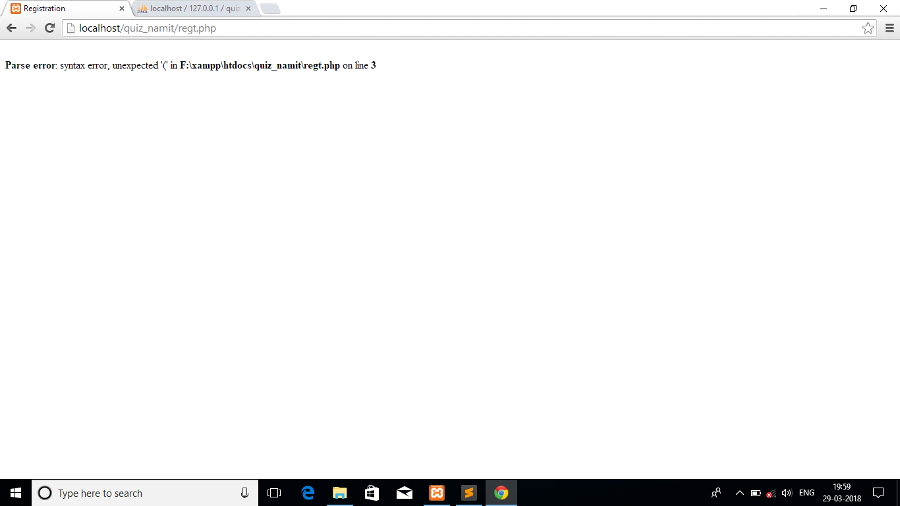

We test our code again and again so that it works fine. Unit testing is very important for any software because if we do the unit testing then when we do the Integration testing then most of the errors we had already removed so it’s easy for us to do the remaining testing.

**5.3 Integration Testing**

Integration testing means suppose we had written the code for registration and login page then we will check simultaneously that whether both the module works fine together that whether flow of data is between them is proper or not.

It is a systematic technique for constructing the program structure. In this testing, many tested modules are combined into the subsystem which are then tested. The good here is to see if the modules can be integrated properly. Integration testing is also an important part of testing. Because if we do the Integration testing in each phase then it will be easy for us to do remaining testing easily.

Example of Intergation testing

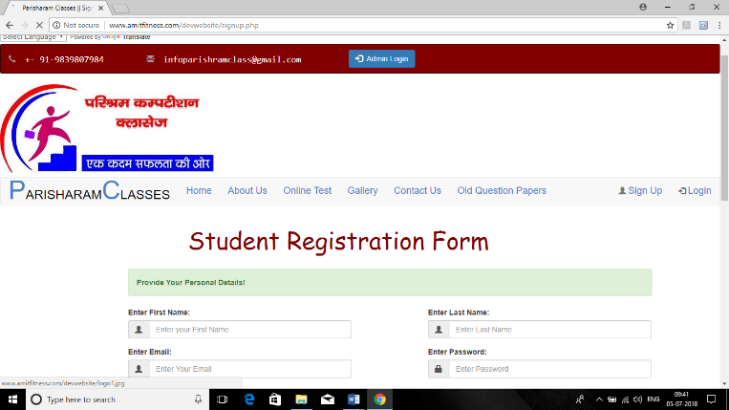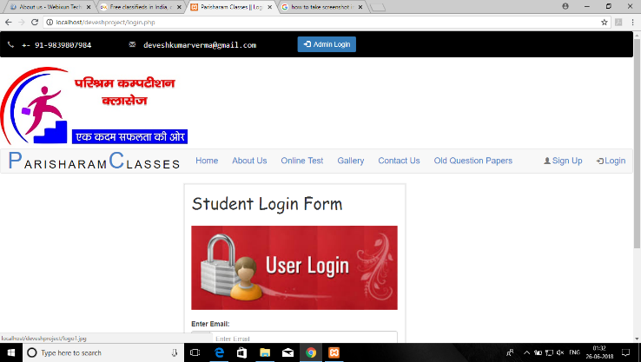

In Integration testing we check the exchange of data between two or more modules. We will check that whether tow modules are working together properly or not.

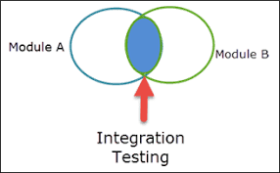

**5.4 System Testing**

System testing tests the system as a whole. Once all the components are integrated, the application as a whole is tested rigorously to see that it meets the specified Quality Standards. This type of testing is performed by a specialized testing team.

System Testing is a level of software testing where a Complete and integrated software is tested. The purpose if this test is evaluate the systems compliance with the specified requirements.

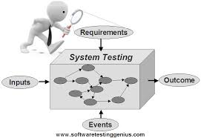

System testing basically a testing in which we test the software that we develop is portable or not that means it is working on client machine or not. For example if I talk about my website then client will upload the questions papers for students now we have to check in system testing that whether out software is supported hat formats of documents or not.

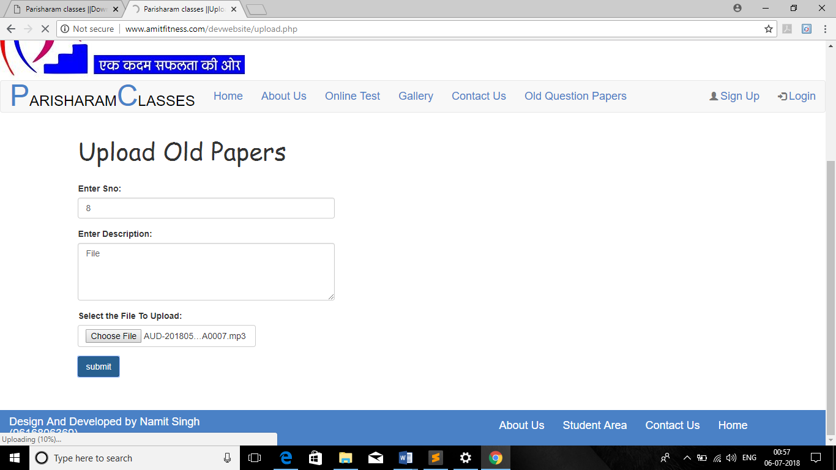

As we can see that it creates problem on uploading questions papers because we are trying to upload the mp3 song here and our code is not allowing to upload that file. So these type of things will come under System Testing

**5.5 Alpha Testing**

When we complete our software then before deliver to the user we do alpha testing .basically alpha testing means nothing special but we show complete software to the client and he/she will test his/her software on the developer end. And if any error find then at that time only developer will remove error completely.

Example of alpha testing:

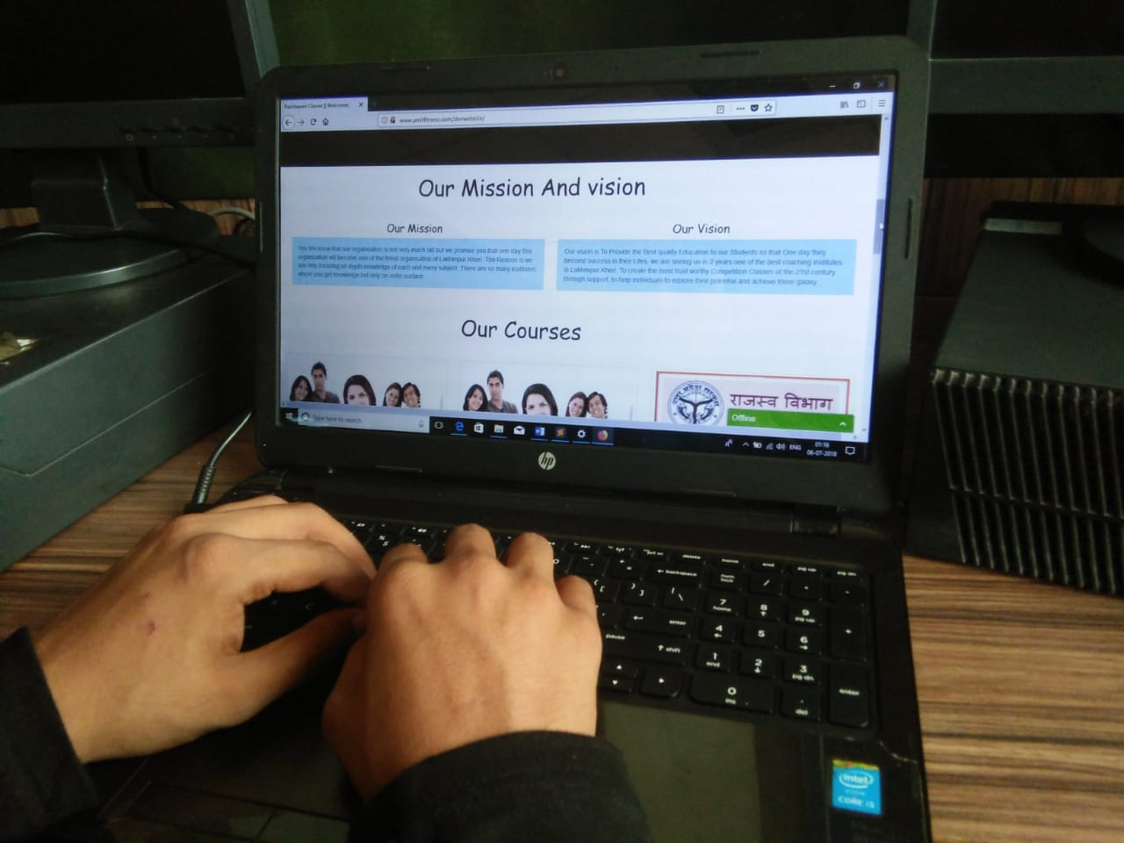

As you can see that client is testing his project on Developers side.so this is the best example of alpha testing.

**5.6 Beta Testing**

Beta testing is somehow similar to the alpha testing but in beta testing client will test his/her project on his own site and if find any errors then he will inform to the developer and finally developer will find the issue and solve the issue.

Beta testing is good as compare to the alpha testing because in alpha testing client will test his/her project on developers end and definitely somehow he will also hesitate and he will not be able to tell the complete problem to the developer.

But I talk about the Beta testing then client will test his/her project on his own site and he will test complete project and inform the developers about all the errors at one time.

**5.7 Acceptance Testing**

This is arguably the most important type of testing, as it is conducted by the Quality Assurance Team who will gauge whether the application meets the intended specifications and satisfies the client’s requirement. The QA team will have a set of pre-written scenarios and test cases that will be used to test the application.

More ideas will be shared about the application and more tests can be performed on it to gauge its accuracy and the reasons why the project was initiated. Acceptance tests are not only intended to point out simple spelling mistakes, cosmetic errors, or interface gaps, but also to point out any bugs in the application that will result in system crashes or major errors in the application.

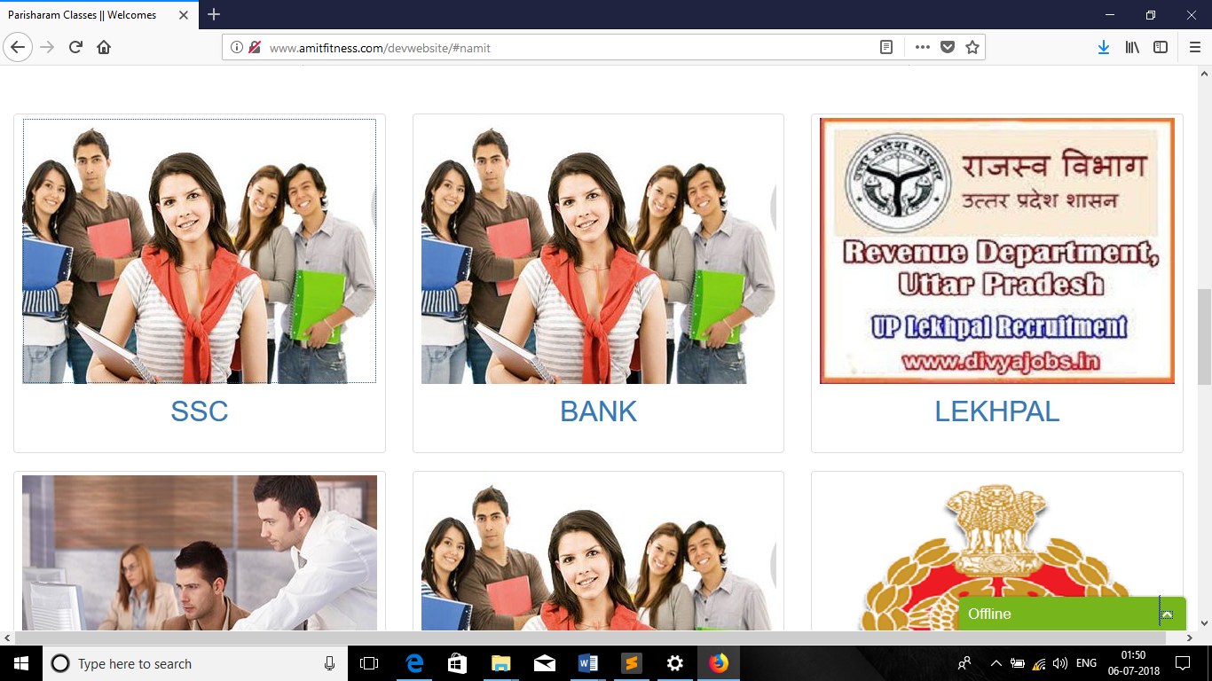

Acceptance testing is a type of testing in which client finally test his/her complete project. Before delivery but this is the final testing done by Client. If project passes this type of testing then the project is ready to deliver.

Chapter 6

Maintenance

**6.1 Defination:**

The Maintenance phase occurs the system is operational. It includes implementation of changes that software might undergo over a period of time or implementation of new requirements after the software is deployed at the customer location.

**6.2 Why Maintenance Required**

Because phase occurs once the system is operational. It includes implementation of changes that software might undergo over a period of time, Or implementation of new requirements after the software is deployed at the customer location.

The maintenance phase also includes handling the residual errors that may exists in the software even after the testing phase.

This phase also monitors system performance rectifies bugs and requested changes are made.

**6.3 Key Deliverables**

**.** Keep System Live

**.** Maintain Code

**.** Update Software When Required.

Basically Maintenance Is what happens during the rest of the Software life changes, correction, additions, moves to a different computing platform and more. This is least glamorous and perhaps most important step of all goes on seemingly forever.

**Chapter 7**

**Scope for future enhancement**

The project has a very vast scope in future. The project can be implemented on internet in future. Project can be updated in near future as and when requirement for the same arises, as it is very flexible in terms of expansion. With the knowledge I have gained by developing this application, I am confident that in future I can make the application more effectively by adding the services. The following are the future scope for the project.

The current application developed is in accordance with the requirement that has been provided by the organization. On regarding the future enhancement, the application can be further expanded in accordance with the changing scenario in the web-based applications that need frequent changes in the changing environment and expansion of the organization.

Since the change in technology and user needs arises frequently in certain short intervals of time, the application can be further upgraded to meet the requirements that may arise in the far or near future. With regarding to the needs that arises, more and more features can be included by adding it as separate modules and integrating it with the existing system.

* + Extending this application by providing Authorisation service.
  + Creating more fields and maintaining users.
  + Increasing the effectiveness of the application by providing webcam features.

**8. Conclusion**

We can conclude that this project enables easy decision making with the support of correct and precise information .Accurate and timely reports as there would be less chance for errors in transactions. The new system can lead to increase in transactions i.e. More billing ,more booking as the computerization speeds up operations ,Increase in revenue due to increase in transactions and prevents loss of revenue .Management authorities can collect reports at any point of time from software. They need not worry about the delay in reports from finance and other departments. Computers can handle large volume of data without any frustrations.

As the software is totally integrated, there is no question of increased data entry problems. As the software comes with very flexible user interface, users will feel very comfortable with new environment.

Thus VIS can be used in places like:-

* Colleges
* School
* Hospital and Hotels

**9. Bibliography**

**References:**

From Client only.

www.w3schools.com

www.youtube.com

www.google.com